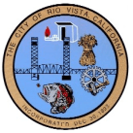 WAIVER AND RELEASE OF LIABILITY 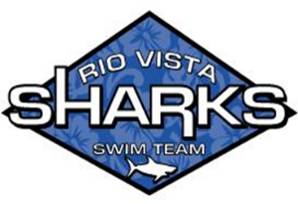

Participant’s Name________________________________________ Phone (____) ______________________
Address ________________________________________________________
City ___________________________________________ State ____________________ Zip ______________
Secondary Phone Number (_____) ___________________ Age ____________

I, the undersigned, certify that I am in good physical condition and wish to use the City of Rio Vista Pool and facilities.

I am aware that serious accidents occasionally occur during swim activities; and that participants occasionally sustain serious personal injury or death and/or property damage, as a consequence thereof. I understand that included among the dangerous elements of swim activities are risks associated with weather, water conditions, including temperature, or injury as a result of being struck by another swimmer or his/her equipment. Additionally, I understand that there is a risk of injury while swimming. I understand that the pool deck, bottom, sides, and starting blocks cannot be guaranteed to be smooth or free of defects, and that there is the risk of injury as a result of tripping or striking an unknown object. I understand that in addition to the above-mentioned risks, there are unpredictable dangers involved in swimming. If, however, I observe any unusual and/or significant hazard I will bring such to the attention of the nearest lifeguard or official immediately and remove myself from participation if necessary.

In consideration of my use of the pool and facilities, I voluntarily release the City of Rio Vista, the Rio Vista Sharks swim team and the Sponsors, or their officers, agents, employees and volunteers from any and all liability for injuries or death, or property damage resulting from or in any way connected with my use of the pool or facilities, that this waiver and release is applicable even though the negligent activities the City of Rio Vista, the Rio Vista Sharks swim team, the Sponsors, or their officers, agents, employees or volunteers may have contributed to the injury or death or property damage, and this document is binding on my heirs and dependents as well as myself. I freely and voluntarily expressly assume all the risks of use of the pool and facilities.

I authorize you to call emergency medical services (EMS) in case of emergency.

I understand that during use of the pool and facilities, I may be photographed. I agree to allow photo, video or film likeness to me to be used for any legitimate purpose by the program officials, producers, sponsors, organizers, or assigns.

Lastly, I agree and abide by the rules and regulations of the City of Rio Vista and the Rio Vista Sharks swim team.

I HAVE READ THIS RELEASE OF LIABILITY AND ASSUMPTION OF RISK AGREEMENT, FULLY UNDERSTAND IT AND SIGN IT FREELY AND VOLUNTARILY WITHOUT INDUCEMENT.

Print Name __________________________________________ Phone (____) ______________________

Signature ___________________________________________ Date: ____________________

